SCREENSHOTS OF THE PROJECTS
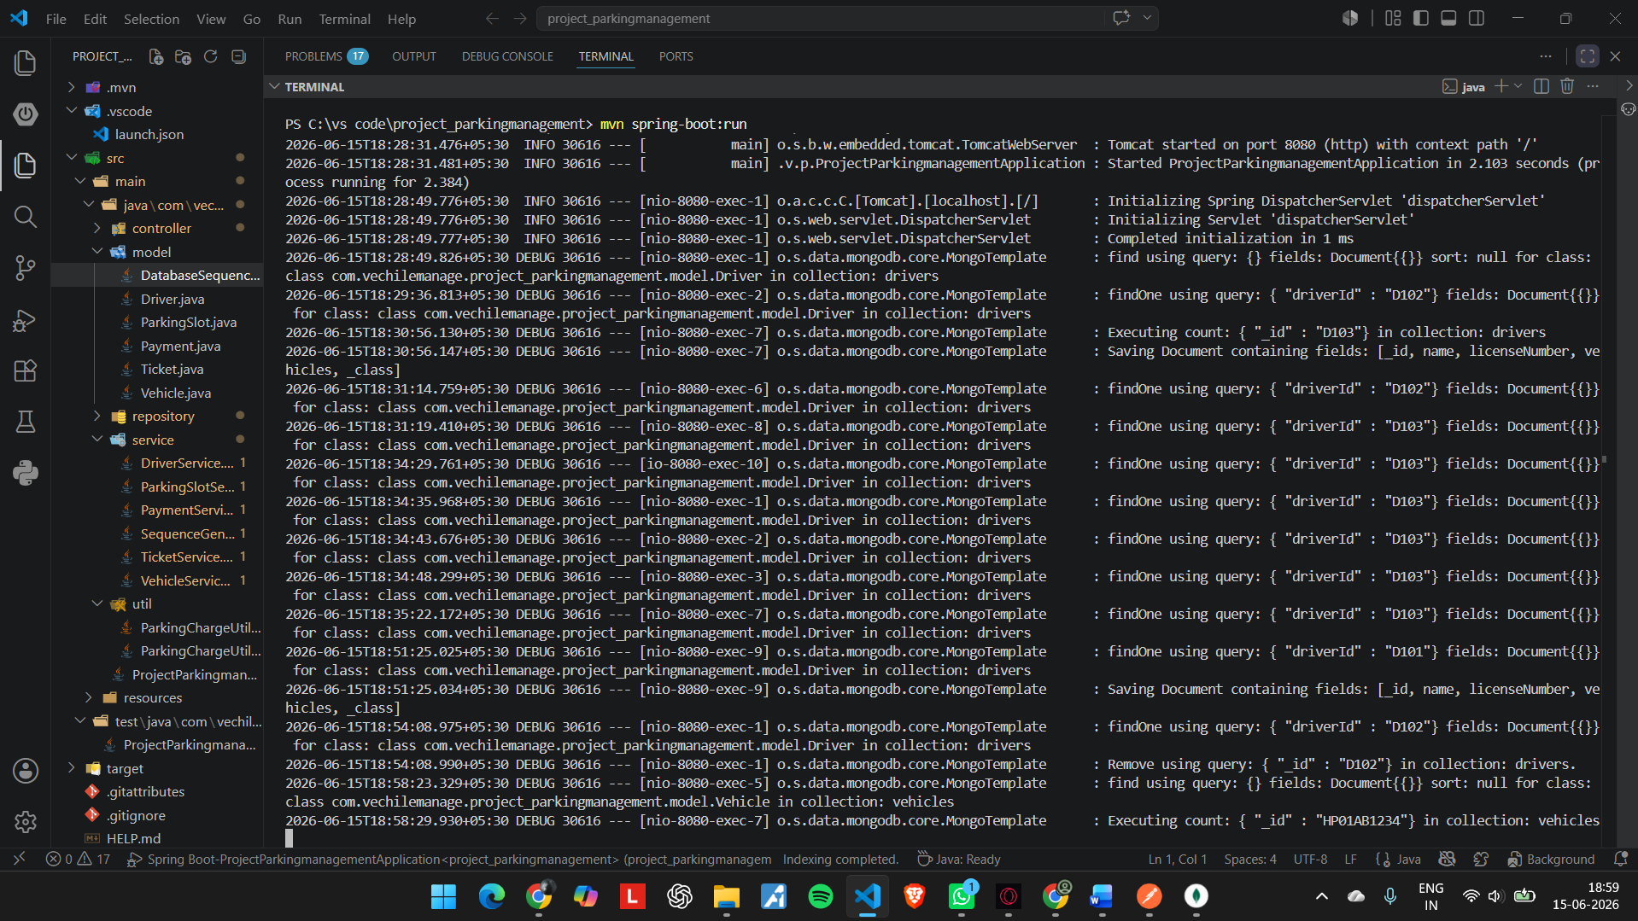
Terminal showing – changes appeared on the Terminal
--------------------------------------------------------------------------------------------------------------------------
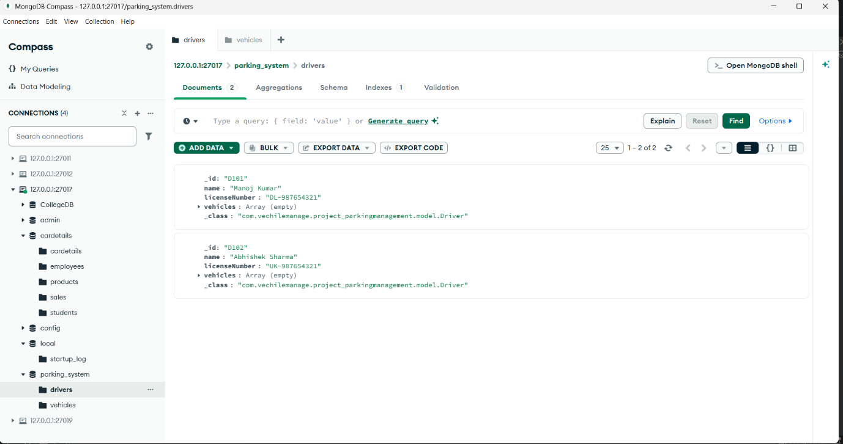
MongoDB_Database_for_Driver( MongoDB Compass)
--------------------------------------------------------------------------------------------------------------------------

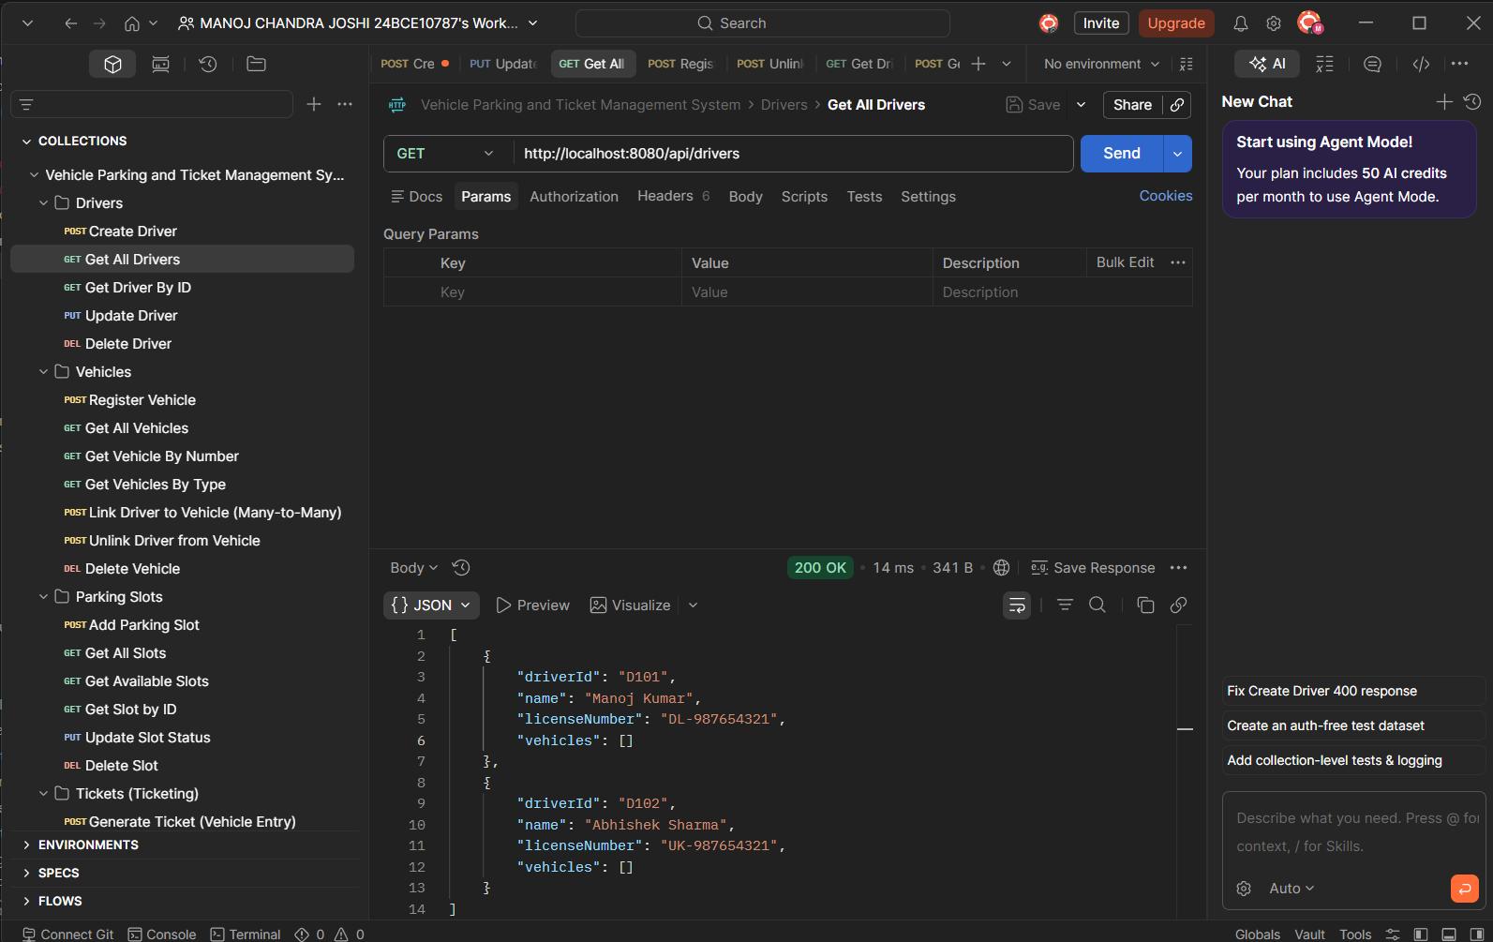
Postman screenshot for DRIVER Method - GET
------------------------------------------------------------------------------------------------------------------------
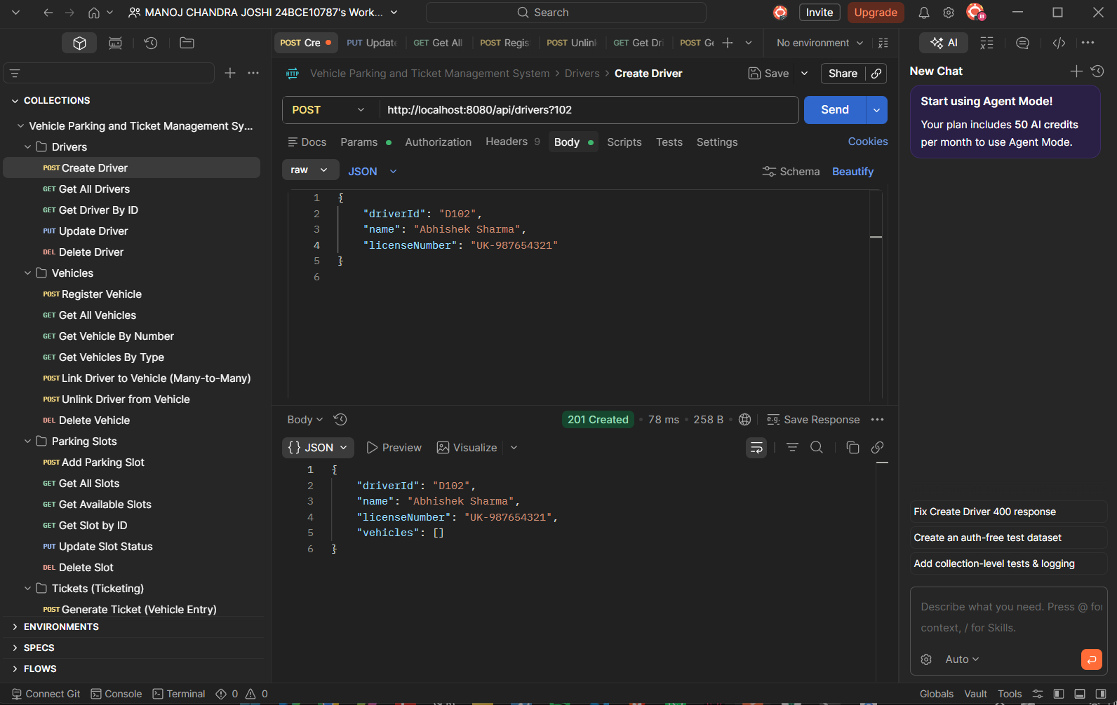
Postman screenshot for DRIVER Method POST
--------------------------------------------------------------------------------------------------------------------------

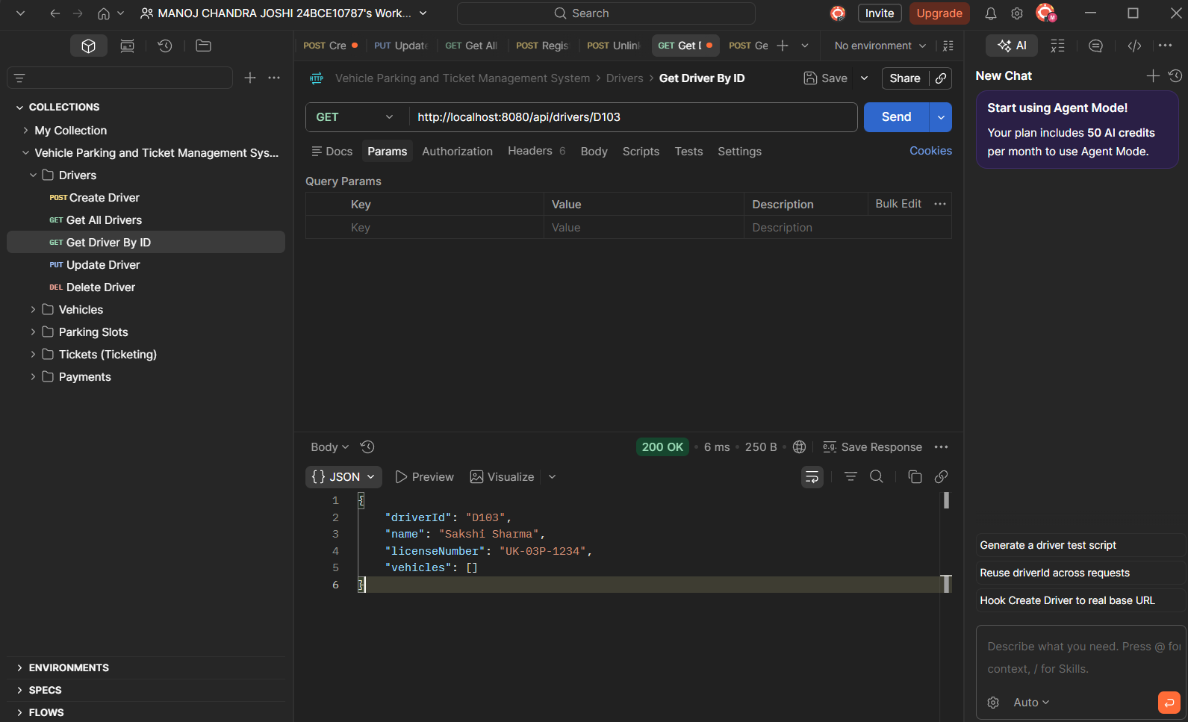
GET Driver by id FIND OPERATION

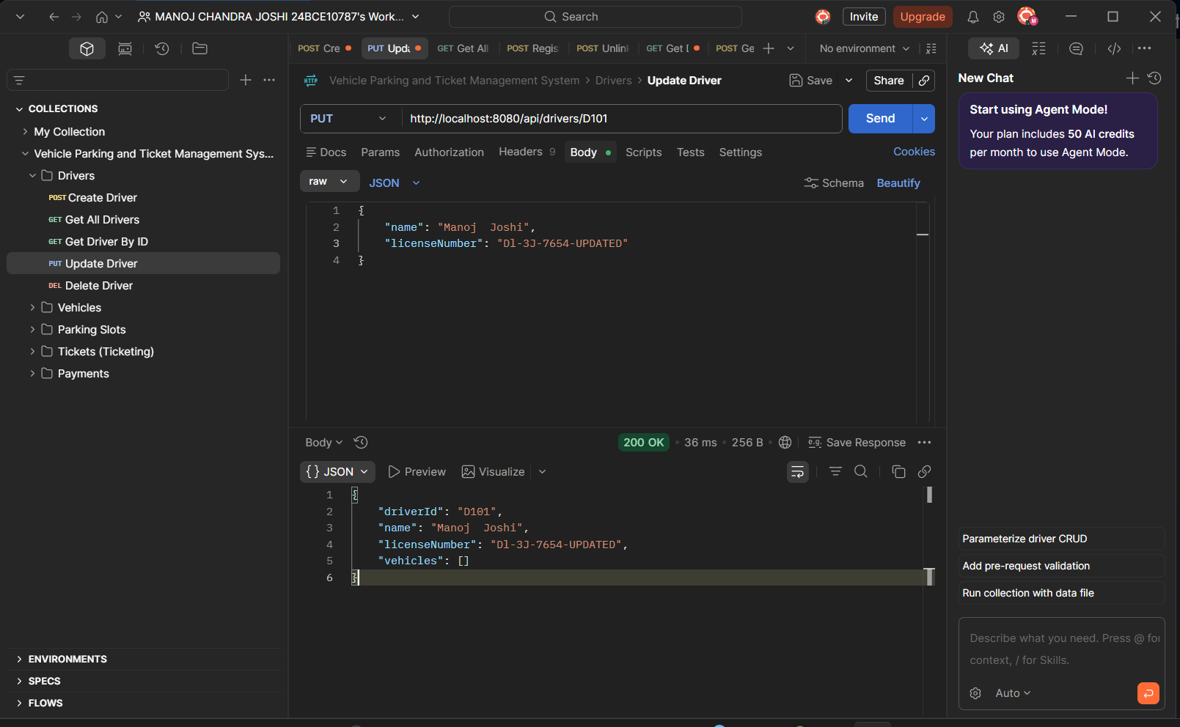
PUT Method used to edit Driver name and licenseNumber for D101
--------------------------------------------------------------------------------------------------------------------------
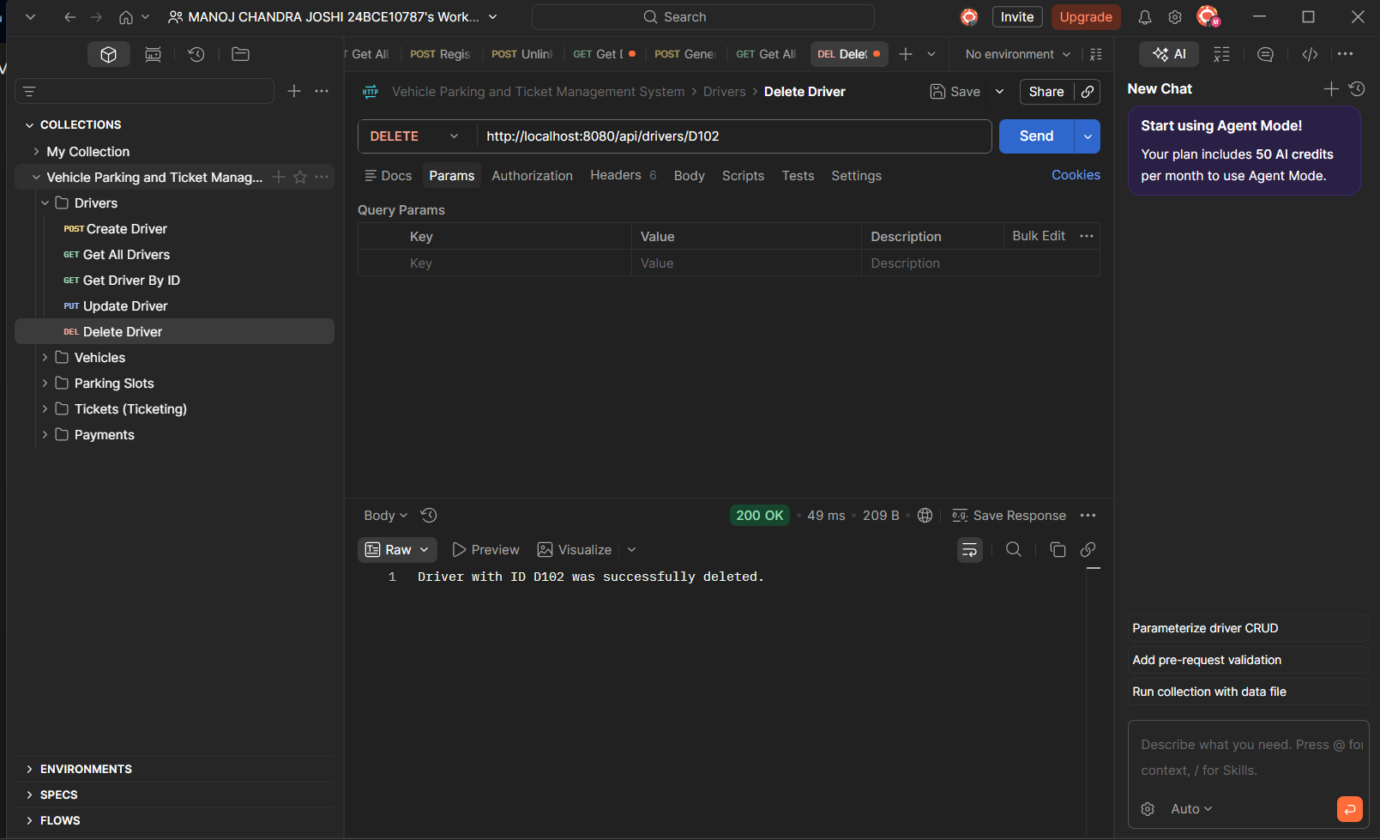
DELETE Method used to delete D102
--------------------------------------------------------------------------------------------------------------------------
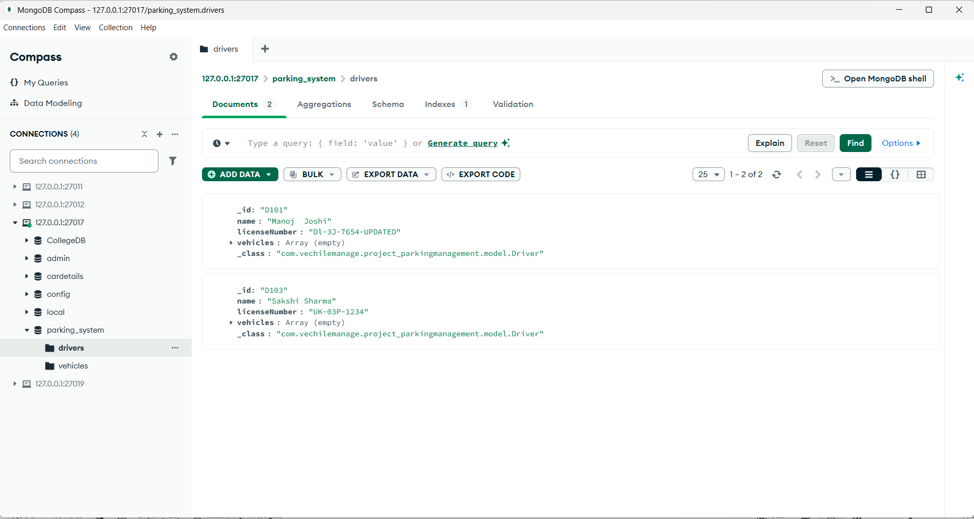
Updated MongoDB Database

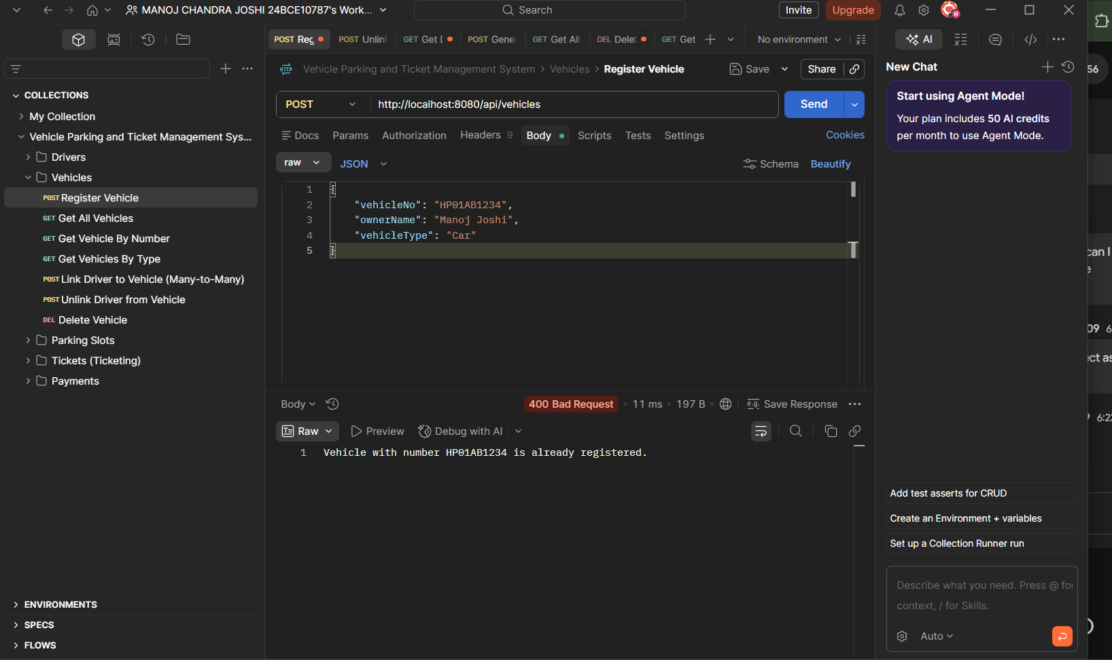
VECHILE SECTION ---REGISTERING VECHILE 400 BADREQUEST AS VECHILENO IS ALREADY REGISTERED
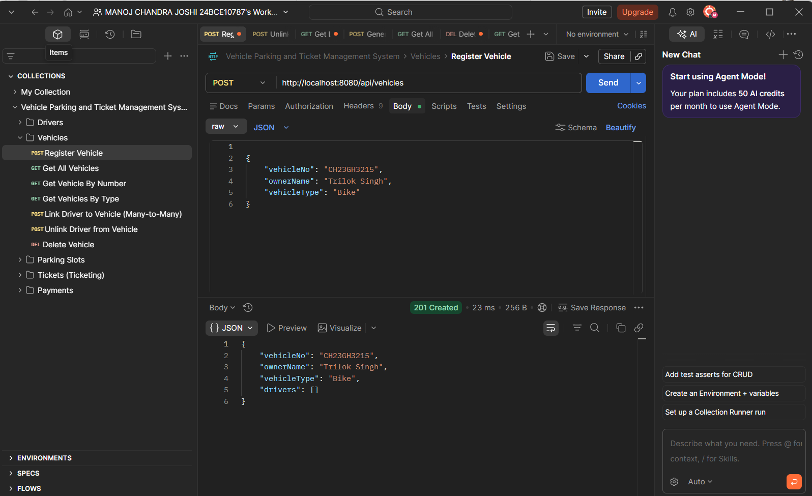
Register VehicleBIKE
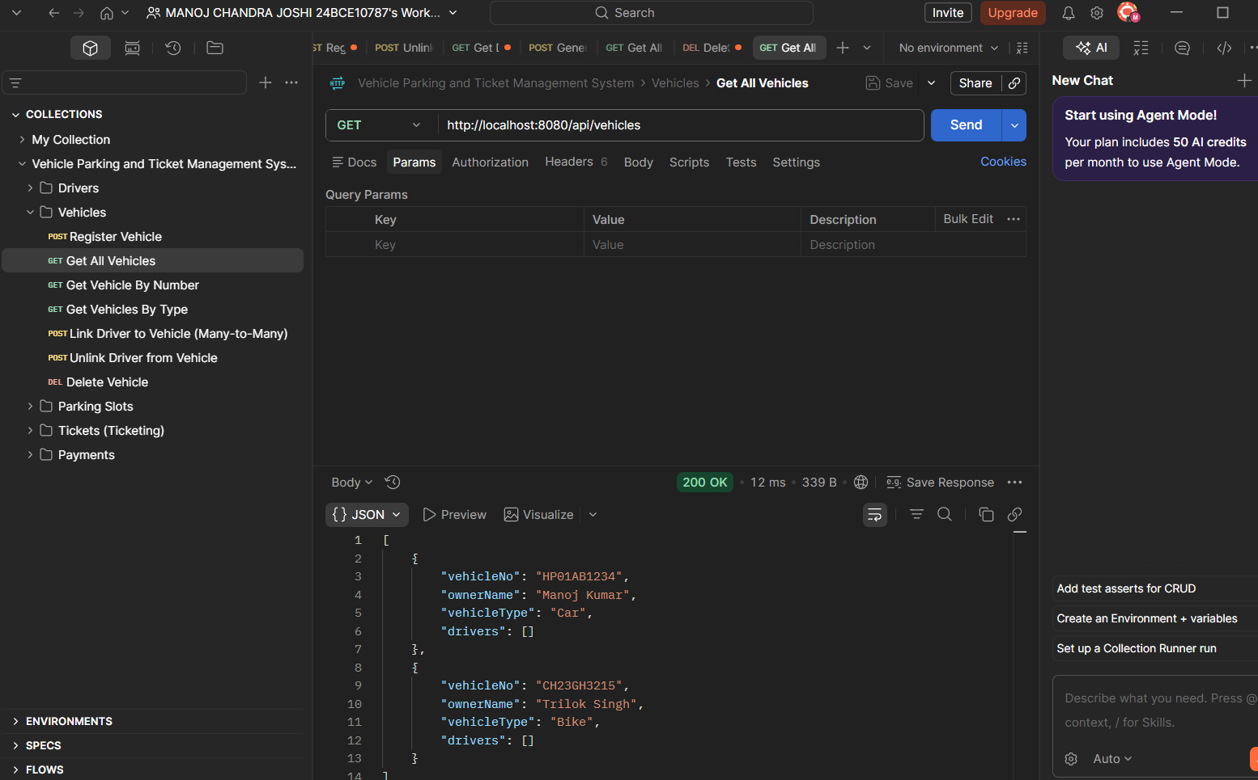
Get data of vehiclespost

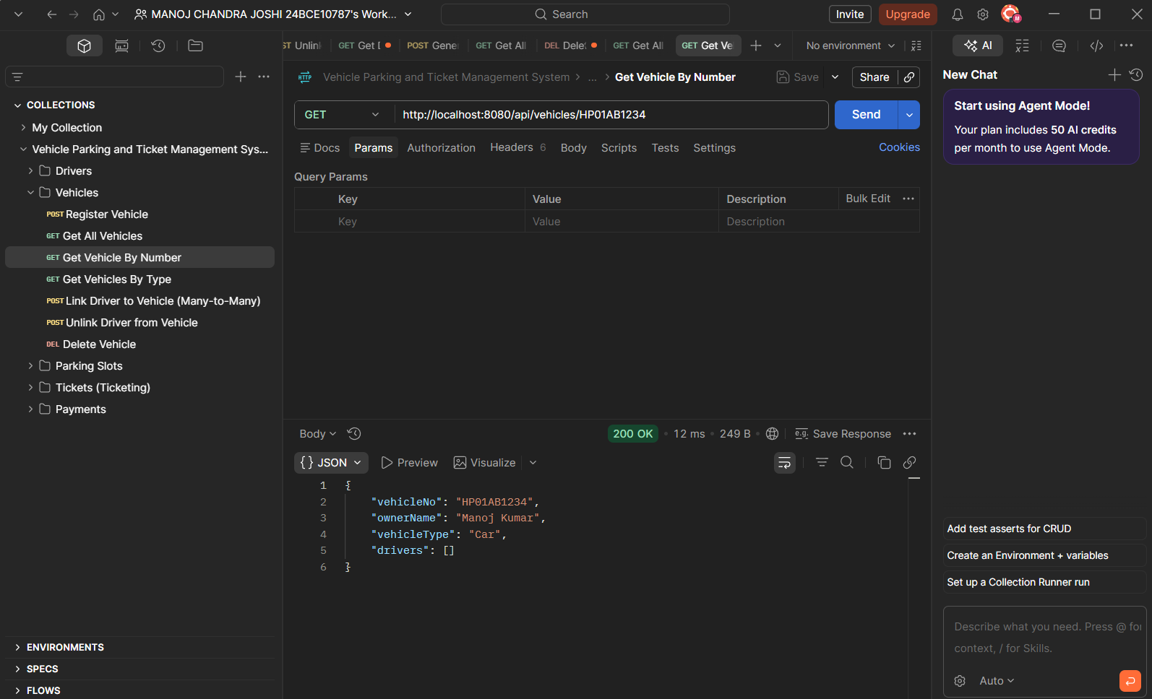
GET VEHICLE BY NUMBER
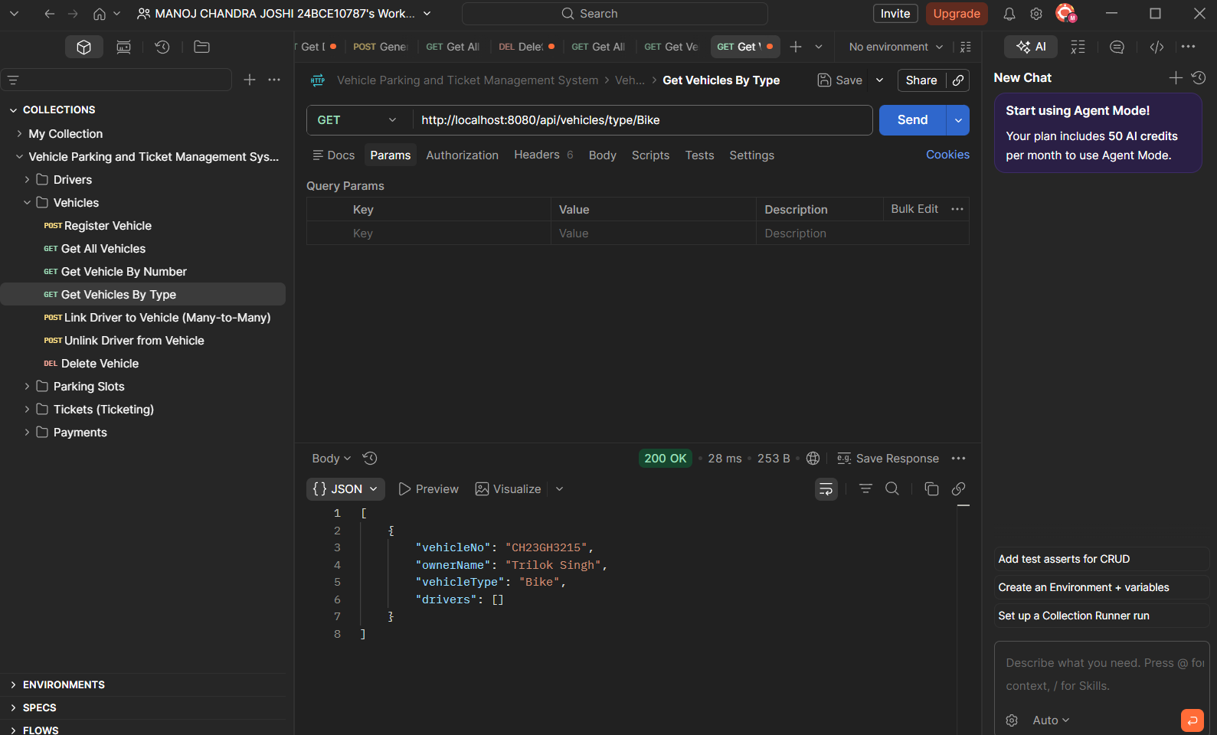
Get vehicle by TYPE

CURRENTLY WORKING ON CONNECTING RELATIONSHIP BETWEEN THE ENTITIES
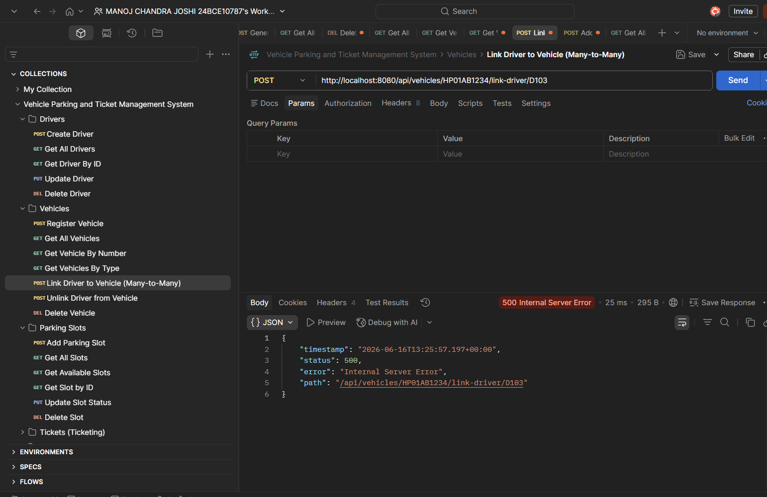

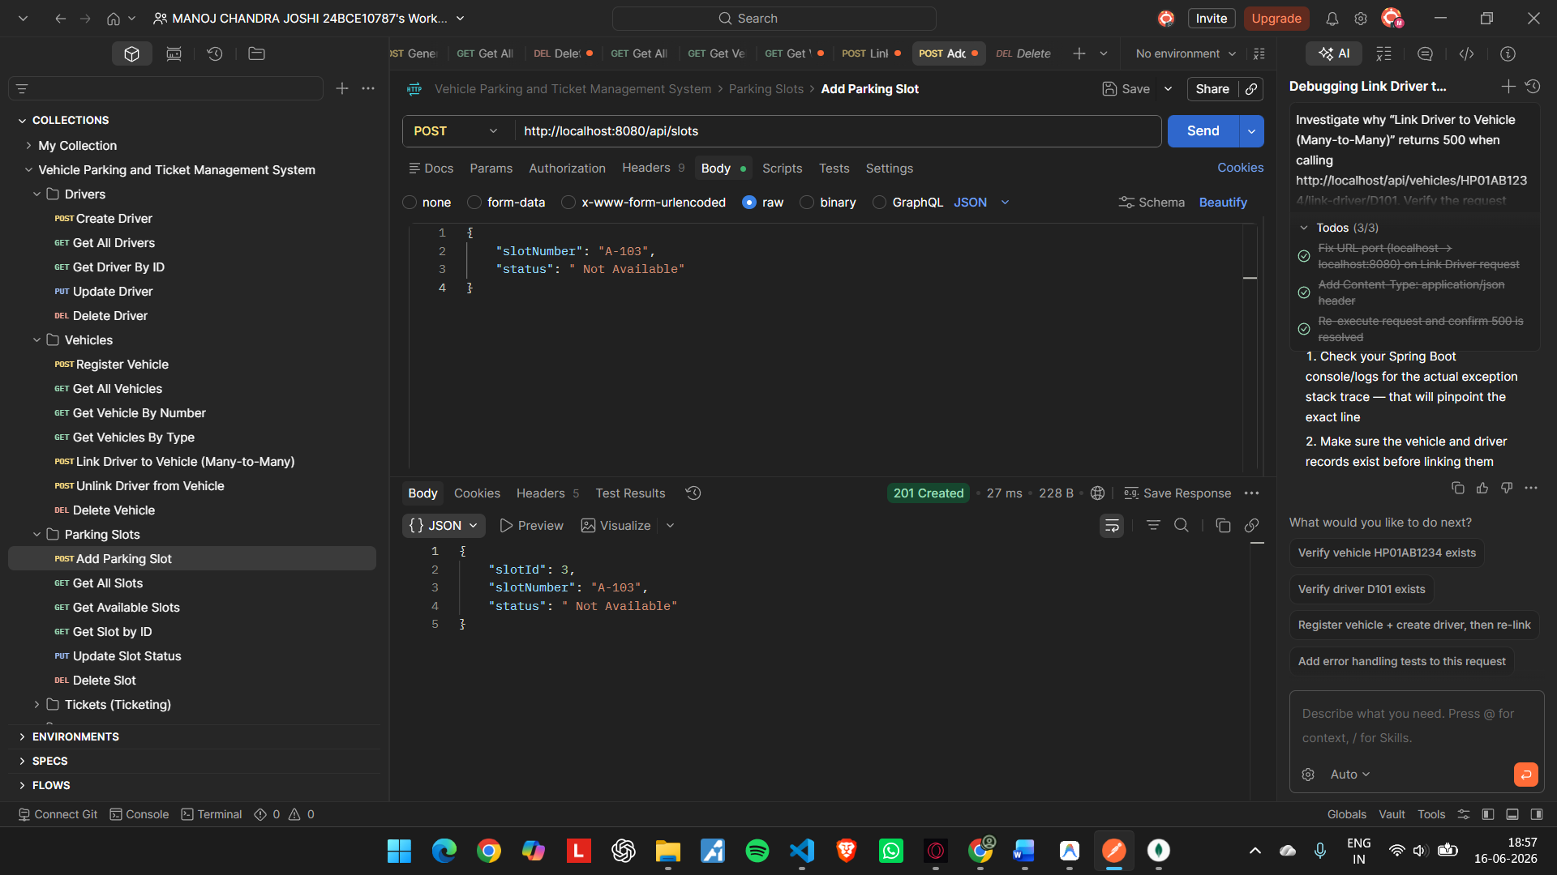
Adding parking slots post method
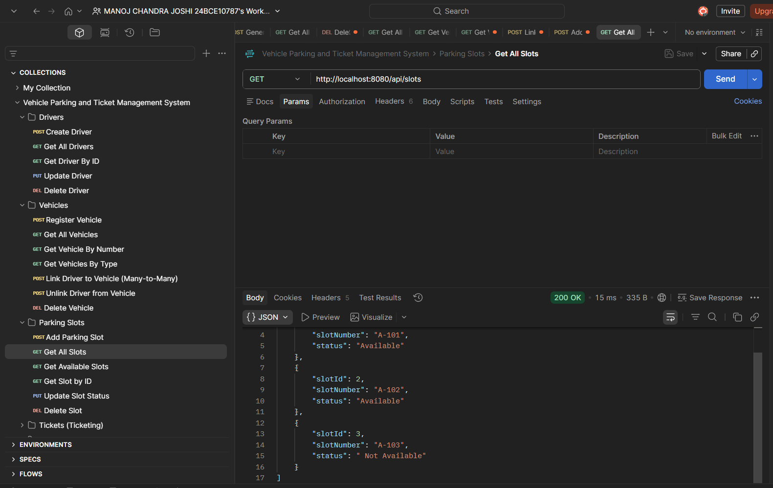

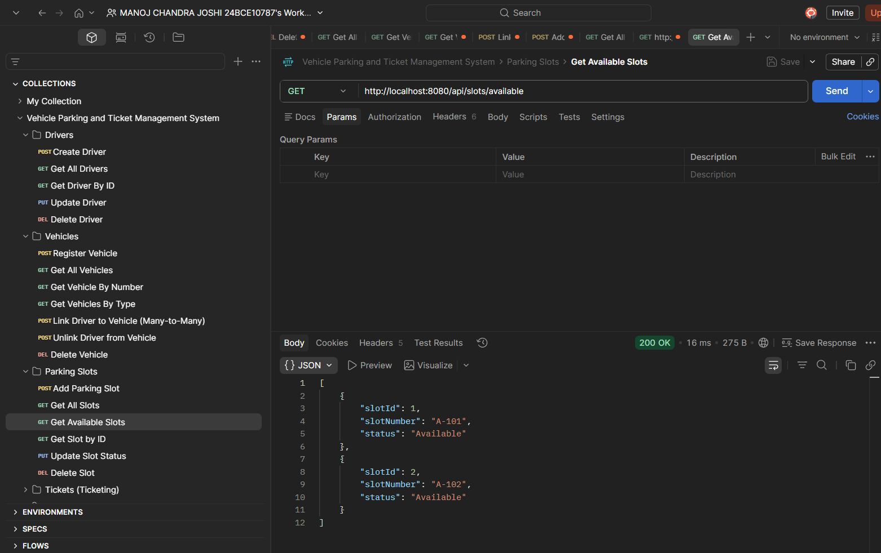
GETTING AVAILABLE SLOTS
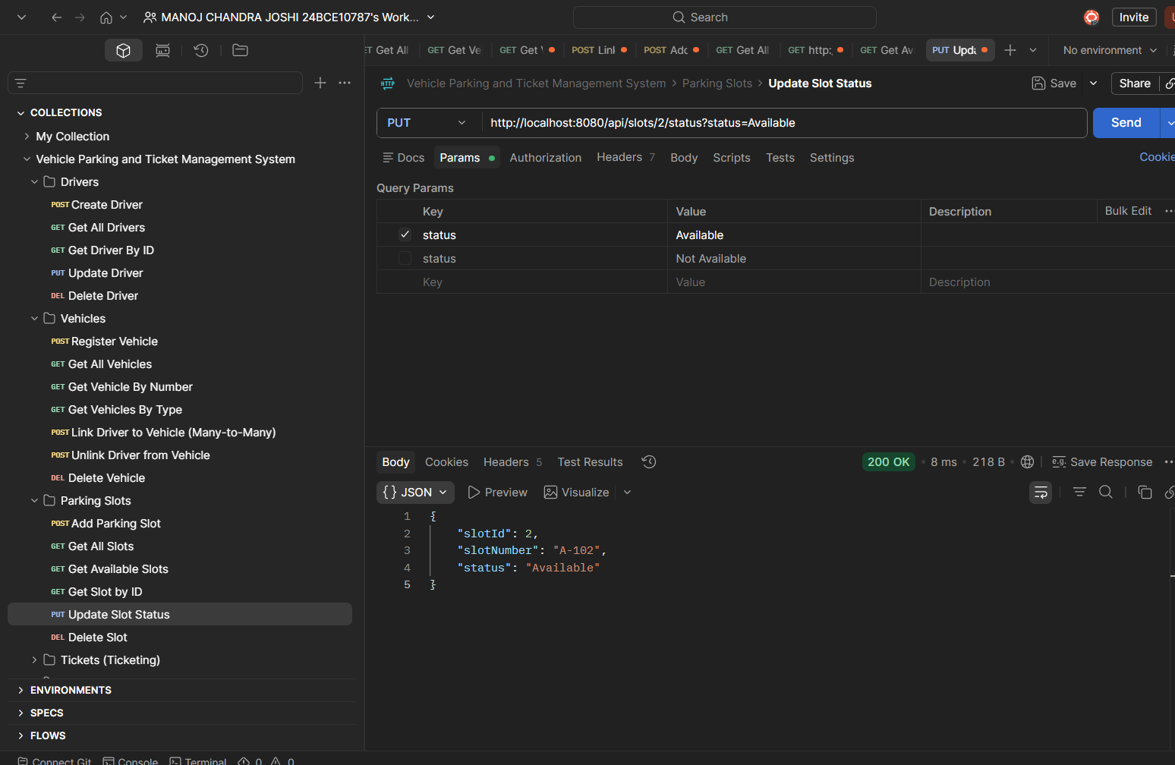

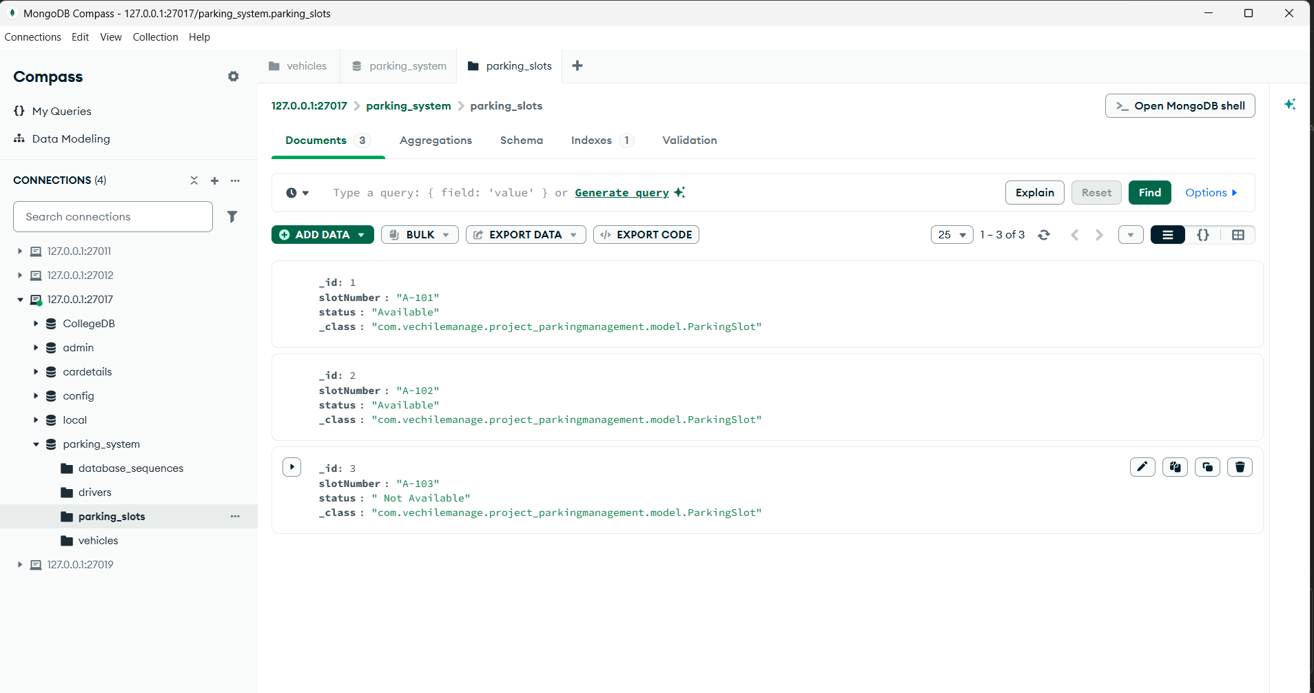
MongoDB database from Compass for parking
